


Portfolio
Team: 10129
Stem October

Grade 10 Semester 1 2024-2025
Names: Samy Mohamed, Islam Essam, Mahmoud Khaled, Mohamed Gamal and Ahmed Hany

Table of contents

Introduction
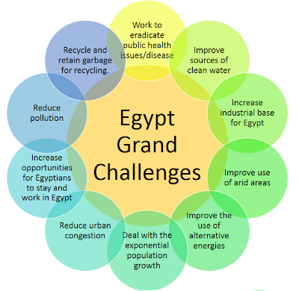
Egypt suffers from many economic, political, and industrial problems. 11 of these problems are the greatest and the hardest for Egypt to solve, which is why they’re Egypt’s 11 grand challenges as shown in Figure 1.
First, garbage and waste recycling. It’s a problem that drives Egypt to higher pollution rates. Second, urban congestion and its consequences. A problem that damages Egypt’s economy and resources. Third, public health issues. Many deaths and suffering happen in Egypt due to this problem. Fourth, reduction of industrial and agricultural areas. This problem is one of the reasons for Egypt's poor economy. Fifth, pollution fouls air, water, and soil. An environment destroyer problem that affects Egyptians’ health. Sixth, improving the use of arid areas. A problem that wastes much of Egypt’s land. Seventh, sources of clean water. Another problem that causes many diseases. Eighth, population growth. The biggest problem in Egypt is the cause of most of the grand challenges. Ninth, improving the scientific and technological environment. It’s a problem that affects the future of Egypt. Tenth, the effects of climate change. The problem that is considered the future cause of world end. Last, use of alternative energy. A problem that if solved, a better life awaits all people.
Figure 1 Egypt's grand challenges

URBAN CONGESTION
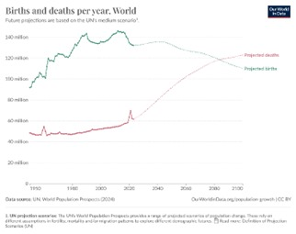
The urban congestion problem is dangerous because it consumes most of the country's resources. The population in Egypt is 106,890,565, according to the Central Agency for Public Mobilization and Statistics (CAPMAS) as shown in Figure 2.

Urban congestion is remarkably high in Egypt, especially in Cario because it contains 10,364,881 people (about half the population of New York) as shown in Figure 2. Cairo is populated with 10% of Egypt’s population while only 0.3% of Egypt’s total area. The average annual growth rate at 1.57%. The Greater Cairo Metropolitan Area (GCMA) contains more than 19 million people which is more than one-fifth of Egypt’s population.
Figure 2 population in Egypt
Urban congestion is a serious problem in the (GCMA) that causes traffic congestion that affects personal travel time, air quality, public health, and business operations.

CAUSES OF URBAN CONGESTION

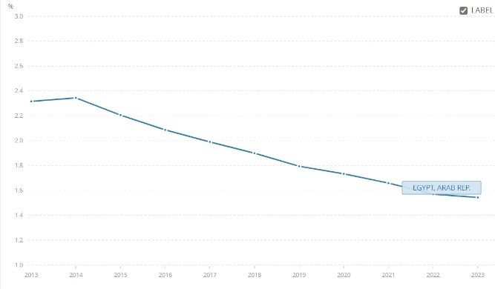
Increase in birth rate
Figure 3 birth rate in Egypt
The birth rate in Egypt is in continuous decrease as shown in Figure 3.
And in 2023 the birth rate is 1.57% as illustrated in Figure 3.

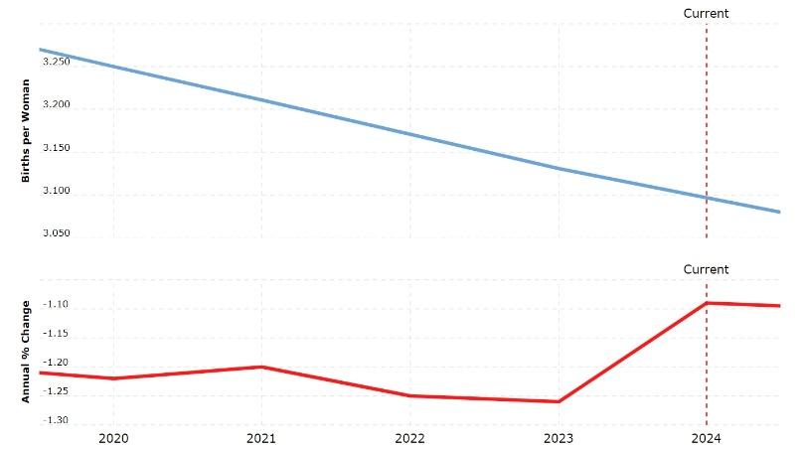
Egypt has one of the largest populations in the Middle East. High fertility in many parts of Egypt causes overpopulation leading to urban congestion. The current fertility rate for Egypt in 2024 is 3.097 births per woman, a 1.09% decline from 2023 as shown in Figure 4.
Figure 3 fertility rate

Figure 4 shows births per woman
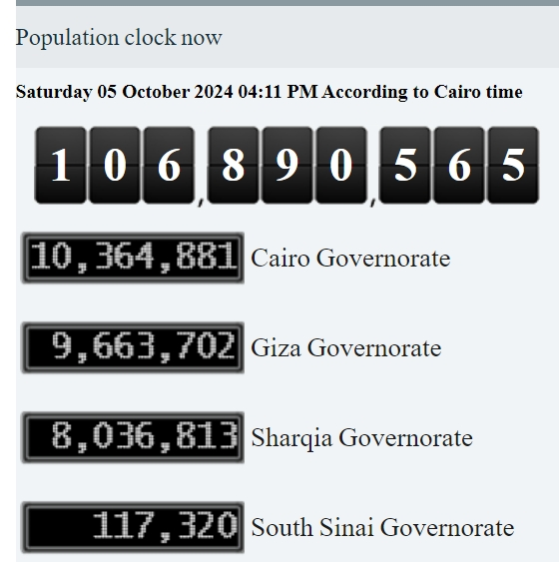
2. Bad people distribution
Egypt’s area is 1002000 KM^2, however, only 105199 KM^2 is inhabited by people. Most of the population is around the Nile banks leaving large arid areas in Egypt, and urban congestion in all populated cities. While the population grows. The population in Egypt centered in Cairo and Giza. There are 18.73% of Egyptians only in these two cities. 10,365,881 Egyptian and 9,663,702 in Giza of 106,890,565 according to the Central Agency for Public Mobilization and Statistics, as shown in Figure 5.
Figure 5
3. Urbanization
Urbanization is the movement of people from rural areas to cities searching for better opportunities. As shown in Figure 6 the growth of Egypt's rural and urban population, in 2023, the share of the urban population in Egypt remained nearly unchanged at around 43.1 percent. Today, the urban population is projected to outnumber people living in rural areas for the first time in 2041. By that time, 69 million people will reside in urban areas.
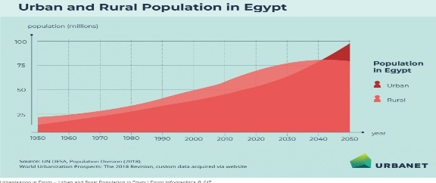

figure 6 urban and rural population in Egypt

IMPACTS OF URBAN CONGESTION

1. Public health
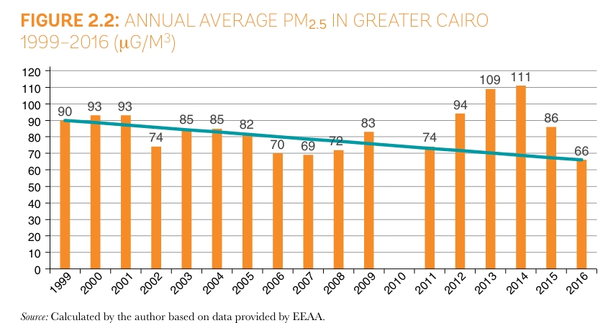
Urban congestion and lack of clean sanitation services increase the risk of contagion, 8.4 million people are deprived of access to improved sanitation, mostly in rural areas. While good urbanization can bring health and benefits for the economy, bad urbanization can have negative health impacts and environmental impacts, 48.1% of all trips are taken by private automobiles which increases air pollution. In air pollution, urban congestion leads to increased emissions from exhaust vehicles making the air quality too poor causing respiration problems and other health problems. In 2019, 16% of deaths in Egypt were due to air pollution and in 2017, 19,200 people died prematurely due to PM2.5 air pollution. As shown in Figure 7 illustrates the PM2.5 in Egypt. The primary source of PM2.5 in the greater Cairo area is load transport 33% and private cars and taxis account for 80%.

Children under 5 with ARI were 10.7 from total Egypt in 2021 as exposed in Figure 8.
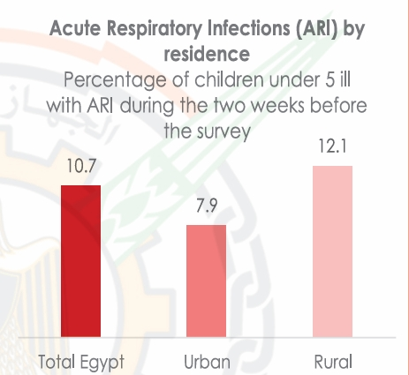
Figure 8 ARI by residence
Figure 7 the annual average PM2.5 in Greater Cairo

2. Social Impact
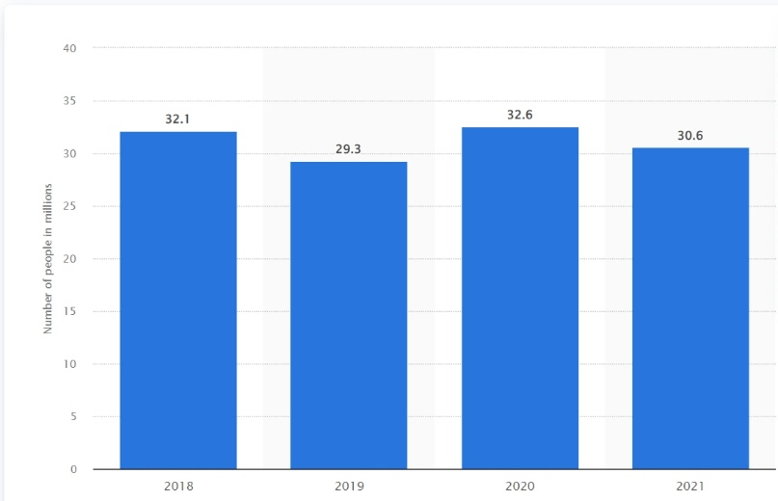
Egypt ranks NO. 35 overall in the U.S. News best countries ranking. Urban congestion reduces the quality of life as there is no time for visiting family, leisure, and rest. This can increase stress and reduce overall life satisfaction. From a social Isolation view, longer travel times can lower social interactions and community engagement. People may be less likely to visit friends and family or take part in community activities if it takes too long to get there. At the Social Inequality level, lower-income individuals who rely on public transportation are often more affected by congestion. Delays and unreliability in public transport can lead to social disparities in society. Urban congestion in Egypt reduces job opportunities as the population is 106,890,565 in Egypt so that increases the poverty in Egypt as illustrated in fig. (8).
Figure 8 NO. of people living under the poverty line in Egypt from 2018 to 2021

Figure 4

3. Economic impact
Urban congestion increases fuel consumption as in 2024 Egypt spends 331 billion Egyptian pounds (6.85 billion) on fuel, while in 2017, fuel consumption in Egypt included petroleum and gas consumption of 27,120 tons per year. The economic costs of traffic congestion in Cairo could be as high as 4 percent of GDP yearly. The economic costs of congestion are beyond travel delays, and they include wasted fuel, health impacts due to poor air quality and accidents, and impacts on economic productivity. When combined, the yearly economic cost of traffic congestion could reach up to 4% of Egypt’s GDP. This means a financial cost to Egypt of up to EGP 50 billion a year (USD 8 billion/year).

Improving the use of arid areas
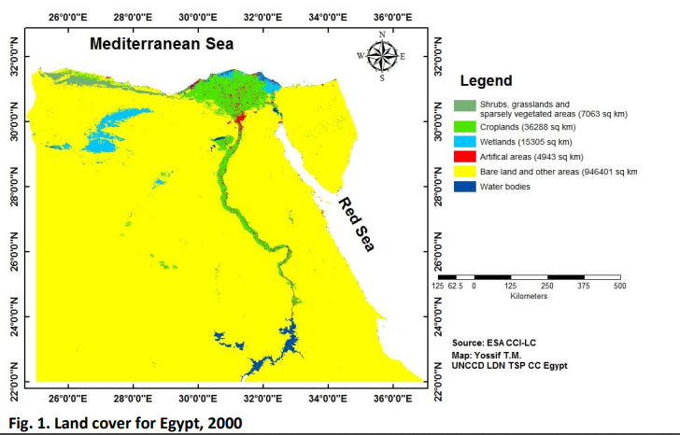
Egypt is a large country that covers an area of 1,002 million square kilometers, The country has a strategic geographic location that connects Asia and Africa and connects the Mediterranean and red seas through the Suez Canal. However, despite the large size of Egypt, it suffers from many problems like urban congestion and insufficient agricultural production. This is because 96% of Egypt’s land is barren, as shown in Figure 9.
Egypt’s desert lands can be split into 3 main areas, The western desert, The eastern desert, and The Sinai Peninsula. Despite low or non-existent agricultural production, these areas produce crude oil and/or natural gas.
Figure 9 barren land in Egypt
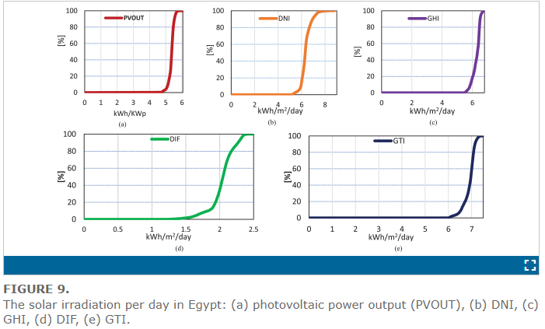
The western desert has 56% of Egypt’s crude oil production and natural gas equals 18% of Egypt’s natural gas production. The eastern desert produces 12% of Egypt’s crude oil. The Sinai Peninsula produces 9% of Egypt’s crude oil. However, all these areas have a very low, barely existent agricultural production, The oases in the region do not make a tangible difference in the overall agricultural production. Therefore, the development of these arid areas for agricultural production is needed. Furthermore, Egypt's geographic location makes it a perfect candidate for solar energy production as the highest direct normal irradiation (DNI) it receives is 3069 kWh/m²/y in south Sinai and the lowest is 1890 kWh/m²/y in Alexandria. The global solar atlas of Egypt is shown in Figure 10.
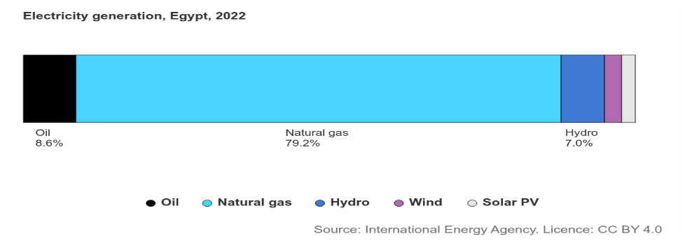
Despite the perfect locations for generating solar power like the Sinai Peninsula, Western Desert and Eastern Desert, solar energy consumption only made up 2.4% of Egypt’s total energy consumption in 2022, which is shown in Figure 11. Which is due to Egypt not utilizing its vast arid areas properly.
figure 10 global solar atlas
Source 1:https://ieeexplore.ieee.org/document/9668970?denied=
Figure 11 Egypt’s total energy consumption

Causes for arid areas
1. Geographic Location
Due to Egypt’s location in north Africa, 96% of the country’s surface area is covered by the western and eastern deserts, both of which are part of the Sahara desert, One of the hottest and driest of the world’s deserts with temperatures reaching up to 57.7 Celsius with extremely rare rain falls as inland Sahara only receives 1.5 cm of rainfall per year, greatly limiting the habitability of the western and eastern deserts in non-coastal areas and making construction of large mines in most of the two deserts extremely difficult if not impossible, and not economically efficient.
2. Land Composition
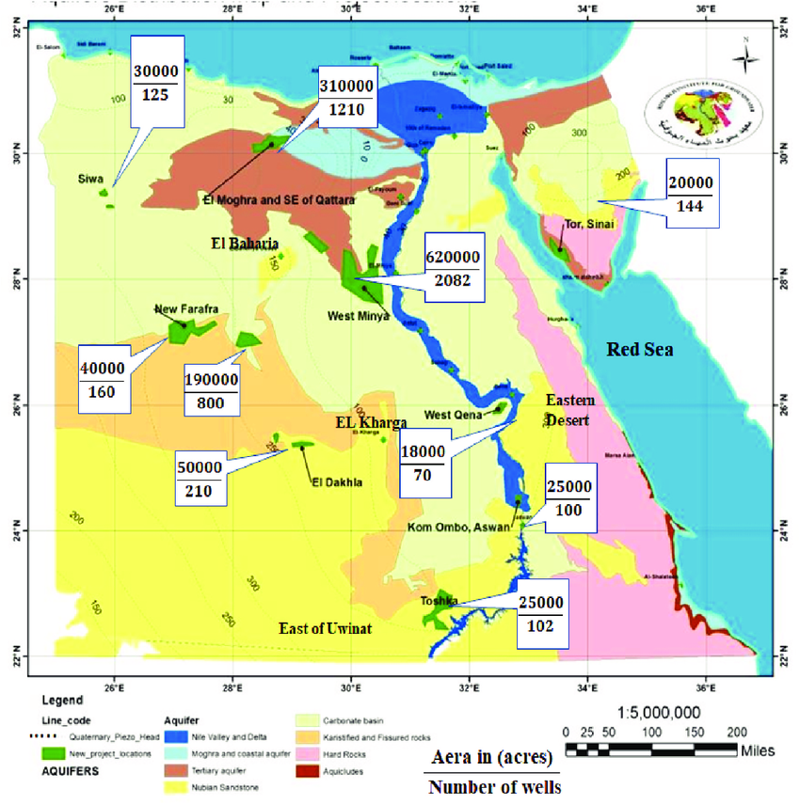
Due to the land composition in the Western and Eastern deserts agricultural production outside of the few scattered oases in them is complicated as the Western desert for example is mostly rocky which is not suitable for agricultural production with 10% of its area being a dune called the Great Sand Sea which is also not suitable for agricultural production as it is a dune. The land and soil composition of the western desert is shown in Figure 12. The most suitable locations for agricultural production in the western desert are the few major oases in the desert, however, the water in the groundwater supplies of these oases is too saline for irrigation for example the water in Siwa Oasis is measured at 2198–14,561 µS/cm conductivity on 96% of the studied water which is above the permitted limit for irrigation that is 700 µS/cm. Such high conductivity resulted from the high concentration of TDS (total dissolved solids) and mineralization of organic materials. The TDS values ranged from 1367 to 8645mg/l. Such high salinity values are likely to be the result of the dissolution of limestone, dolomite, and evaporite deposits in the area. Consequently, The Western desert and the eastern desert soil are not suitable for agricultural production in their current state.
figure 12
Figure 12 The land and soil composition of the western desert
5 figure 4

3. Lack of Water Resources
The arid areas of Egypt lack water resources as the only water sources in Egypt (apart from oases and groundwater) are the Nile River and smaller bodies of water near it like Lake Nasser as 90% of Egypt’s water supply comes from the River Nile alone with an annual share of 55 m3 billion, according to the United Nations Department of Economic and Social Affairs. Arid areas away from the Nile River must instead depend on groundwater and rain. Since arid areas like the western desert only receive 1.5 cm of rainfall per year (except for the north Mediterranean coast) they must depend on groundwater instead. Groundwater in arid areas, for example, the western desert in oases like Siwa Oasis has water conductivity measured at 2198–14,561 µS/cm which is higher than the permitted 700 µS/cm for irrigation, Limiting the uses of groundwater in the region even more and making it more difficult to utilize the arid areas.

Impacts of arid areas
1. Population Increase in the Nile
As a direct result of mismanaging the arid areas (96% of the total area) of Egypt and not utilizing them to their fullest potential, it has caused problems for Egypt, one of which is urban congestion along the Nile River banks and Delta (4% of the total area) as more than 90% of the population (more than 96 million people) live along the narrow Nile banks due to it being the only water source besides lakes like lake Nasser and groundwater scattered across the country and being the agricultural hub of Egypt.
2. Agricultural Production Deficit
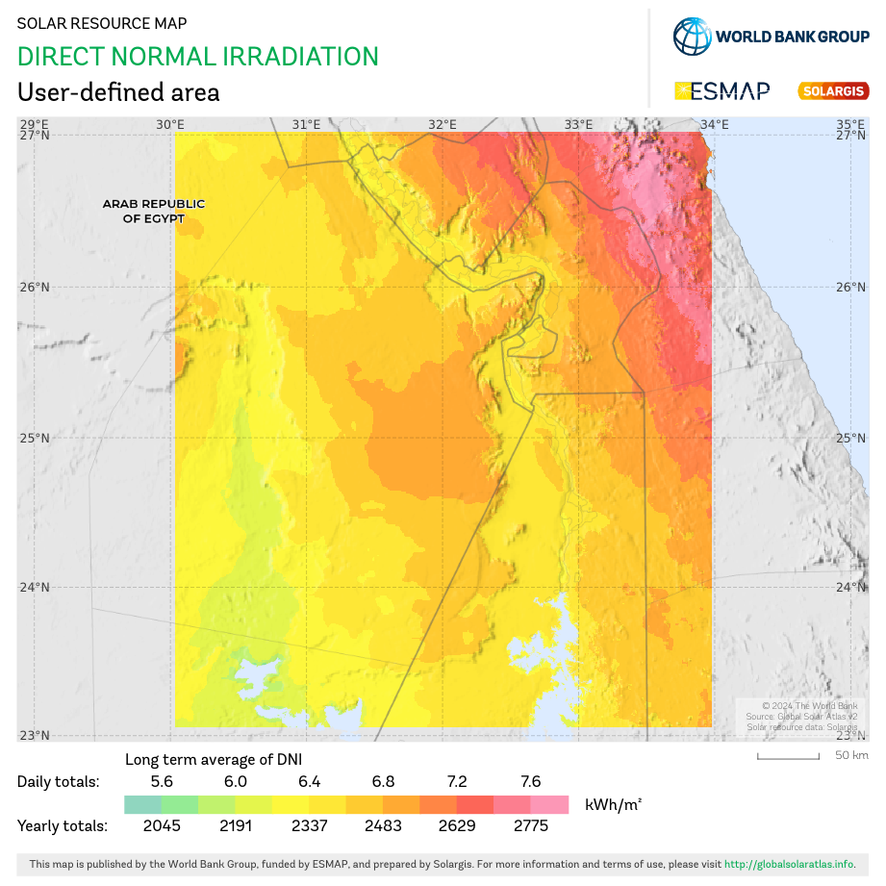
96% of Egypt’s surface area is a barren desert with harsh conditions, not suitable for agricultural production. Only the remaining 4% which equals 40,058 square kilometers of land are suitable for agricultural production which is insufficient for the Egyptian population of 106 million people. This forces Egypt to rely on imports to satisfy its deficit in agricultural production, As Egypt imports 40% of its food requirements which has an annual cost of 2.5 billion USD according to FAO. This is due to Egypt not fully utilizing its arid areas, especially for agricultural production.
figure 13 mean wind power density at 100m in the new valley area

3. Insufficient Solar Power Utilization
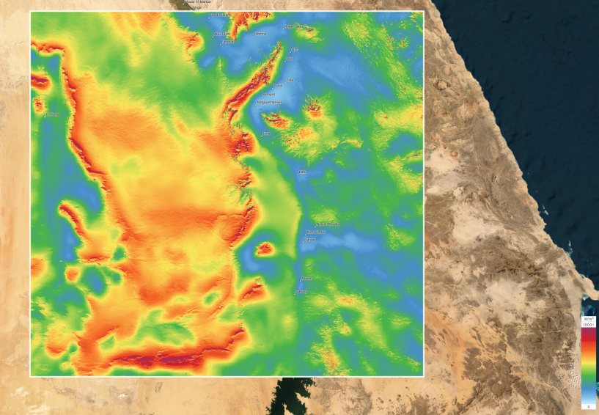
Only about 4% of Egypt’s energy consumption which was is solar energy and wind energy, which is a low percentage compared to the possible solar and wind energy output of Egypt due to the mean power density it receives. For example, the mean wind power density at a height 100 meters south of the western desert in the new valley is 716 W/m² as shown in Figure 13, and the direct normal irradiation it receives, which is equal to 5.95-7.12 kWh/m2 as shown in figure 14. This low percentage comes back to the expensive price of the wind turbines, solar panels, and batteries needed to generate enough solar energy to satisfy Egypt’s electricity consumption, the time needed to construct the wind turbines and solar panels, and the maintenance cost of the solar panels and wind turbines due to the climate of the arid areas in Egypt.
Figure 14 mean wind power density at 100m in the new valley area

Population growth
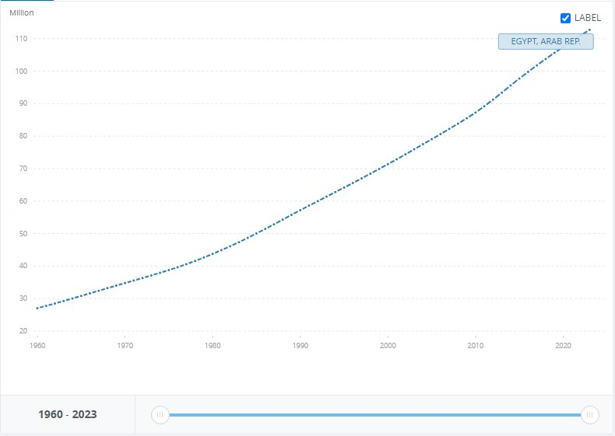
One of, if not, Egypt’s greatest grand challenges is population growth. Over the years, the population in Egypt severely increased with a high ratio, causing huge problems.
As shown in Figure 15, the population went from 27M to 112M in 63 years with a 314% increase in population and 2% growth a year. Birth numbers exceeding deaths’ makes Egypt more and more crowded than ever in each minute passing. So over only 63 years, there are 85M more people living on the same space, resources, food, and national income while a lot of them don’t work because of high unemployment.
Figure 15 Population in Egypt
The reduction of resources and hard life for the individuals living in Egypt are the consequences of population growth. Making it a difficult challenge for Egypt to face.

While some cities in Egypt are the most populated, for instance, Cairo itself is populated with 10% of Egypt’s population, 10,364,881 in numbers. When it’s only 0.3% of Egypt’s total area, equal to 3,085 km^2. Showing how bad the population distribution is in Egypt.

Causes for population growth

1. Early marriage

In the past years, it was a tradition that girls should marry early. Marring at the age of 13 and 14. In the countryside and southern Egypt, it’s considered a shame to reach 20 years old without marriage. Which makes a large number of births in a short period of time. Exceeding deaths and growing population.

16% marry under the age of 18. And 2% marry under the age of 15. This means 1 in 6 women is married before their 18th birthday. In total 8.1M women are wed under 18 to date according to UNICEF. 15.8% of child prevalence in Egypt in 2021.

2. Bad population distribution

Egypt’s area is 1002000 KM^2, however, only 105199 KM^2 is inhabited by people. Most of the population is around the Nile banks leaving large arid areas in Egypt, and urban congestion in all populated cities. While the population grows. The population in Egypt centered in Cairo and Giza. There are 18.73% of Egyptians only in these two cities. 10,365,881 Egyptian and 9,663,702 in Giza of 106,890,565 according to the Central Agency for Public Mobilization and Statistics.

3. Poverty

27% of Egyptians were below the poverty line in 2023. Poor people marry early and give birth in large amounts, hoping their children will take care of them although, increasing population growth and the poor.

The current fertility rate for Egypt is 3.097 births per woman. Approximately 10M children live in poverty in Egypt, nearly 3 in 10 children and 28.8% of children live in extreme poverty according to UNICEF.

Impacts of population growth

1. Pollution
Population growth increases pollution severely. Egypt is ranked 9th in air pollution. And Egypt holds the 12th position in the global pollution index, with a score of 82.7 making it one of the most polluted countries in the world. Emissions from vehicles, industrial processes, and agricultural activities are the reasons for high pollution levels.

2. Economic pressure
Egypt’s spending in 2023/2024 reached 3 trillion EGP. Marking a 34% increase from the previous year. And the more population growth the more money Egypt needs to provide essential needs for its civilians. While Egypt’s revenue for the year 2023/2024 is only 2.14 trillion EGP, putting Egypt under high economic pressure.

- Housing shortages:
The rapid growth in population in Egypt caused a horrible experience for its people. The housing shortage is a problem that Egyptians face because of the population growth. Poor families are the most affected by this problem as according to a research paper done by the CIA, formal housing stock grew from 1.8M to 2.1M in 25 years, and in those years, urban households grew from 2M to 4.5M. It means that a lot of Egyptians are endangered to be homeless.

Recycle Garbage and Waste for Economic and Environmental Purposes

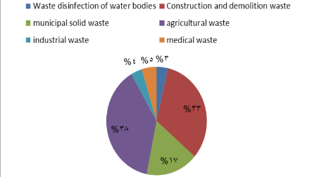
Egypt is a large African country that lies in the Middle East. In the last few years, Egypt has faced a hard, grand challenge that affects Egyptians’ daily lives. Which was pollution. Pollution has been prevalent in Egypt, especially in known regions such as the Nile Valley region. Egypt’s environment has been exerted gloomy influence by pollution. Also, Egypt is producing 75 million tons of various types of solid waste annually, as shown in Figure 16.
Figure 16, Egypt Production of urban solid waste
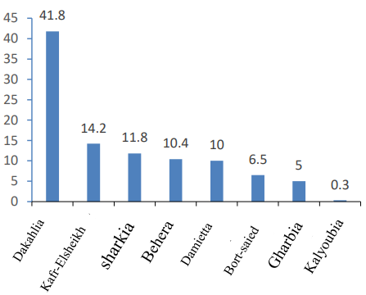
Egypt has tried to commence it by working for the safe disposal of waste and garbage, which causes this pressing problem. The Most effective way for the Egyptian government and the Egyptians is to recycle the garbage and wastes. The A.P.E )Environmental Protection Association) in cooperation with The EISWR (Enhancement of Integrated Services Promotion and Waste Recycling Company), was addressing the garbage and pollution problem in Egypt through many approaches to recycling the waste. Nevertheless, pollution is rising day by day.
Figure 3, Egypt Production of urban solid waste
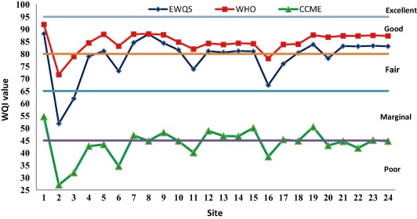
Amounts of garbage are getting high levels on the streets and public areas, waste is becoming more ubiquitous in the governorates, and nature is damaged because of this. For example, there are 635.224 tons per year of garbage in Assiut Governorate is collected. Also, there are amounts of agricultural garbage generated by some governorates have reached 3.6 billion tons in 2020, as illustrated in Figure 17. In addition to that, there are around 4 billion cubic meters of agricultural and industrial raw sewage dumped per year in the Nile River. They contain acids, organic compounds, pesticides, inorganic nutrients, etc.; all of them are contaminating the river and decreasing the WQL (Indices of Water Quality), as shown in Figure 18.
Figure17, Percents of agricultural garbage amounts generated in these governorates in 2020

Figure 18, Levels of WQL in Nile water
Recycling is a perfect way to solve pollution with its forms, like water pollution in the Nile River, the Red Sea, and some of the oases. And agricultural problems. But Egypt’s government hasn’t worked better on it.
Causes:
- Growth and population crowding
Egypt’s population equals to around 106 million people in the middle of 2024. That means there is a lot of garbage. The population in Egypt is increasing dramatically per year. There’s a relationship between the increasing population and the effect of the environment which is a significant issue. For example, most governorates to produce garbage in 2022 were the most crowded governorates with a population like Cairo with 23.3%, Giza with 10,4%, and Qalyuobia with 6.4% of all Egypt production of garbage that reached 76.6K tons per day.
- Egyptian Industrial Sectors
In Egypt, the industrial sectors significantly contribute to environmental problems, which especially affects negatively on the agricultural soil and water quality. As the 2021 report from the Egyptian Environmental Affairs Agency (EEAA) said, over 60% of Egypt's industrial waste is inadequately treated. The thing leads to that soil is polluted. In addition to that, the Egyptian Ministry of Water Resources and Irrigation has reported that about 30% of industrial wasted water is discharged without treatment into the Nile River, which spreads water pollution. Additionally, there are around 22 million tons of solid waste per year according to the Solid Waste Management Regulatory Authority (WMRA). Also, the amount of untreated or partially treated industrial pollutants that enter the water supply is estimated at 4.5 million tons per year. Because of that, there isn’t effective waste management in Egypt, there are around 28% of waterways cleaning waste, 1% hazardous waste, 1% medical waste and only 5% of waste from the industries are generated, although the industrial sectors are the main cause of most of these amounts.
- Inefficient Waste Management Policies
Egypt's increasing garbage problem is mostly caused by ineffective waste management regulations. A large portion of waste ends up in open spaces or illegal dumpsites due to improper collection and disposal caused by unclear regulations and enforcement. For example, a significant amount of municipal solid waste goes uncollected, with only roughly 60% of it being formally collected. Cities like Cairo and Giza struggle to handle their enormous daily waste output due to inadequate infrastructure and funding. Furthermore, depending too much on the unregulated recycling industry, which manages 80% of recycling, leads to inefficiencies and environmental risks. These disparities cause serious pollution, which lowers the quality of the air, water, and soil and raises health risks in low-income areas. Putting in place contemporary waste management systems,
Impacts:
- Healthy Impacts
The amounts of garbage and wastes which are not generated well in Egypt areas and regions have severe health impacts. Poor waste management is reason for pollution in water sources, increasing the prevalence of diseases as like cholera and typhoid, especially in low-income areas. The World Health Organization (WHO) has reported that waterborne diseases affects on 20% of hospitalizations in Egypt. In addition to that, around 50% of children in Egyptian slums are suffering from diarrhea because of untreated waste and unsanitary conditions in these areas. To add, a report says that 38 million people drink polluted water from Nile and other resources. It pointed out that the high rates of poisoning cases are caused by pollution from the different cities of Egypt. On water, around 100,000 people are diagnosed by injuring with cancer per year because of waste in water.
- Economic Impacts
Egypt generates about 75 million tons of waste annually, according to AUC Knowledge Fountain report in November 2021. With 22 million tons of municipal solid waste. The illegal handling of these amounts of waste costs the economy around 1.5% of the GDP because of the health impacts and the loss of tourism. For instance, Egypt loses about 100 million dollars annually due to the environmental degradation in tourist destinations in the country. Also, a statistic approved that 2.8 million metric tons of plastic waste were leaked into the Mediterranean each year, and Egypt is by far the largest source, accounting for 43% of the total, according to the Worldwide Fund for Nature (WWF). The informal recycling sector accounts for 80% of recycling efforts but lacks regulation. Additionally, a study reported that the GDP is lost in Egypt by about 5.7 billion dollars per year due to non-recycled waste.
- Environmental Impacts
The over-increased amounts of garbage in Egypt severely harm the environment. There are large amounts of garbage that remain uncollected, especially in rural areas where collection rates are as low as 0–35%. This waste is leading to severe land and extensive pollution of the Nile River and other water bodies as lakes and Egypt's two seas. Also, roughly 56% of this waste is accounted for as organic waste, which contributes to high methane emissions when it decays and worse changes in Egypt's climate and weather. For instance, Egypt contributes around 1.5 million tons of plastic waste annually in coastal areas; most of these amounts lay and end up in the Mediterranean Sea according to the Worldwide Fund for Nature (WWF). In addition to that, about 40% of garbage in cities such as Cairo is uncollected, which affects solid health and leads to land pollution threatening biodiversity.
Problem to be solved
Urban congestion
Urban congestion is a frustrating problem. Facing every Egyptian, and being a great grand challenge for Egypt. With a 2% growth rate of population a year, Egypt becomes more congested.
For instance, Cairo and Giza have a sum of 18.73% of Egypt’s entire population. 20,028,583 of 106,890,565 in numbers. Cairo itself is the most congested city in Egypt with 10,364,881 Egyptian equal to 9.7 %.
While the area of Cairo is 3,085 KM^2, being only 0.3% of Egypt’s area. Having 9.7% of Egyptians living in only 0.3% of Egypt, Explains why Cairo is positioned 57th in global traffic congestion behind cities like New York, London, and Paris. Showing the bad distribution of population, being the main cause of Urban congestion.
Teraat Al Ismailiyah Road is a main road in Egypt. Being the main road connecting Cairo with El Ismailiyah governorate and El Swiss canal. It being so important is a reason for its congestion, as it is 218 km long and with a width of only 18m. It’s over congestion makes it hard for cars to travel this long distance, meaning it’s the perfect road to search for a solution.
Urban congestion is a factor in most of Egypt’s problems, for example, pollution, traffic accidents, and fuel consumption, affecting Egypt’s economy. So by searching and analyzing the challenge of urban congestion, soon a solution will be found.

Positive consequences

1. Less pollution
Car exhausts are major pollutants in the air. Contains three major air pollutants that are harmful to the environment which are: carbon monoxide, nitrogen dioxide, and carbon dioxide according to SOUTHWESTOHIOAIR.org.
Car pollution is 33% of Cairo’s air pollution concentration according to CLEANAIRFUND.org. This is a huge deal considering Egypt’s 12th position in the global pollution index and 9th in air pollution.
Urban congestion is a fatal cause of car pollution. By solving it pollution will severely decrease by at least 10% by avoiding the combination of car exhaust pollutants. Having cleaner air, a less polluted environment, cleaner and healthier food, and cleaner water to drink from (as main roads are common around the Nile).

- Reduction of traffic jams
Due to urban congestion Egypt suffers from traffic jams on all its main roads. As a result of the close working hours in Egypt, being around 8 AM to 4 PM varying in different companies. The main roads always expect traffic jams around 7 AM and 4 PM. Causing a lot of traffic accidents,
according to a report of the central agency for public mobilization and statistics (CAMPAS), road accidents in Egypt has reached 71.016 just in 2023 while it reached 55.991 in 2022 with 27% increase only in one year. And the injury rate was 67.5 per 100,000 people in 2023 while being 54 per 100,000 with an increase of 25%.
Solving the urban congestion problem would reduce traffic jam and save large amounts of lives as traffic accidents’ deaths are 1.89% of total deaths ranking Egypt at 116th in traffic accidents’ death rate. And faster transportation inside Egypt will be reached.

- Economic and health benefits

Reducing urban congestion would reduce Egypt’s spending severely. as urban congestion causes the need for more resources to provide the services for Egyptians.

According to the global hunger index in 2023 Egypt sustains a moderate level of food insecurity, ranking 57th out of 125 countries. Egypt has a large water supply by having the Nile river but the congestion in cairo and Giza leads to over use of the water around it affect the quality of the water. according to capmas, 98.7% of Egypt’s water supply is through the Nile while only 66.7% of the population benefits from sanitation services leaving 33.3% drinking unsafe water. Making solving urban congestion benefit able.

Negative consequences

- High noise levels
The congestion in cities results high noise levels. The noise levels in Cairo are at 90dB, which can be compared to spending all day in a factory. While sounds over 85dB are considered a damage to your hearing. And it’s only safe to listen to sounds lower than 70dB.
Repeated exposures to loud noise can lead to permanent tinnitus and /or hearing loss, physical and psychological stress, reduce productivity, interfere with communication and concentration.

- Public health risks
Urban congestion is one of the main reasons of infection diseases and health pandemics. Peoples’ breaths in congested cities consuming oxygen and producing carbon dioxide polluting the air, risking the health of Egyptians. Congested vehicles’ exhausts gives the risks of lung diseases. The pandemics of infection diseases have higher risks as they are transported through air and breaths.

Research

Topics related to the problems

- Population in Egypt
One of the main topics to research on the urban congestion problem in Egypt is Egypt’s population. Being the main factor of urban congestion in any place. Since urban congestion is the congestion of the population in a certain area it’s essential to know about the population in the rural areas.
When researched on Egypt’s population it’s found out that the total population in Egypt is 106,890,565 growing by 1.57% since 1960 till 2024.the most populated cities in Egypt are Cairo, Giza and Sharqeia governorates which are 10,364,881 in Cairo, 9,663,702 in Giza and 8,036,813 in Sharqeia. Cairo being Egypt’s most congested city ranking 6th in most populated cities in the world falling after new York and London.

- Over pollution in Egypt

One of the main problems worldwide being the main cause for climate change and it’s mainly caused in Egypt by urban congestion which is why researching on it is important for identifying urban congestion.

When researched on pollution in Egypt it’s found that Egypt is ranked the 9th in air pollution. And Egypt holds the 12th position in the global pollution index, with a score of 82.7 making it one of the most polluted countries in the world. Cairo itself scores 95.8 out of 100 10 times above the safe limits being globally one of the most polluted cities in the world.

- Unemployment rate
One of the miserable consequences of urban congestion is unemployment. Due to the huge numbers of people there aren’t enough jobs to be provided for each person, being an important topic to search about.
Egypt’s unemployment rate is 6.40% of population, a 1.04% decrease from 2021 at 7.44%. the highest unemployment rate Egypt has reached was 13.40% in march 2014.

Topics related to solution

- Highway network
Highway network is one of the main factors of sustaining urban congestion for instance, Multilevel highways are multiple highways elevated over each other.
The road network in Egypt 65.050km long, 48,000km are paved. And the network of highways covers the country extending around 18,000km, Egypt is ranked 18th in global ranking of road quality advancing 100 countries.

- Flyovers and Overpasses
Flyovers and Overpasses are elevated roads built over critical congested road to reduce the congestion of traffic used on major and critical roads and highways
There are 4,159 flyovers and overpasses constructed over major roads in Egypt, as reducing traffic and urban congestion and improving connectivity between major roads.
- Supports
A support is a part that is used on flyovers or bridges to support the deck and distribute the weights.
There are many types of supports, for instance, fixed support, roller support, pinned support and simple support, however, the most common used in Egypt is the hinged support for opening bridges and the ixed support for fixed decks used in 100% of the bridges of these criterias
Other Solutions Already Tried

Hawthorne Bridge

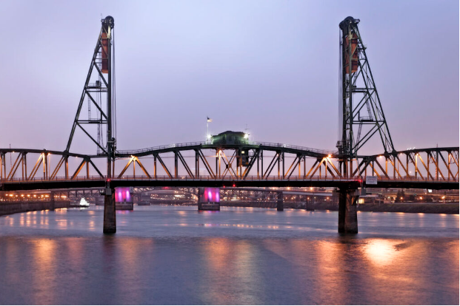
Hawthorne Bridge in Portland, USA is a 1082-meter-long, 22-meter-wide, 4-lane vertical lift bridge shown in Figure 19, it connects Hawthorne Boulevard and Madison Street by crossing The Willamette River. Originally constructed in 1910, It is the oldest operating vertical lift bridge in the United States of America, it is one of Portland’s busiest bridges, it can hold traffic of 30,000 motor vehicles/day, Including 800 TriMet buses, 8000 bicycles, and an untold number of pedestrians daily. It was designed by Waddell and Harrington, Consulting Engineers from Kansas City and MO. It opened to traffic on December 19, 1910, it was named after Dr. James C. Hawthorne, a physician and politician who co-founded the Oregon Asylum for the Insane in the 1850s. The bridge is of large importance due to connecting Hawthorne Boulevard and Madison streets which, in addition to their transportation importance, are home to many local businesses, which makes connecting them useful and important. In addition to the latter, according to Multnomah County, the bridge is used heavily by pedestrians and cyclists on a regular basis which adds to its importance. According to Transportation History in 2012, Hawthorne Bridge was added to the National Register of Historic Places in the USA which further proved its importance to Portland and the United States as a whole.
Figure 19 Hawthorne bridge

Mechanism

Hawthorne Bridge is a vertical lift bridge that uses a system of counterweights and cables to move the lift span straight up and down. A vertical lift bridge is a bridge where the entire deck is lifted vertically by pulling on the four corners using two or four towers at either end of the open span while remaining horizontal. While the maximum height it can be raised is determined by the height of the towers, this system allows the bridge to be raised to the minimum height for a ship to pass beneath it, therefore minimizing the opening time and delays to traffic on the bridge. The operation of the bridge is by cables fixed to the open span. These cables pass over the top of the towers and are fixed to counterweight. The mechanism makes sure that the bridge travels upwards and the counterweights downwards. This ensures that everything is balanced during the vertical movement. The presence of the counterweights minimizes the amount of energy needed to raise the bridge.

Points of Strength

Transportation Importance
Hawthorne Bridge continues to serve as an important transportation route between downtown Portland and the South Waterfront neighborhood, which provides important access to various businesses, residences, and other important venues.

Historic Importance
Due to its uniqueness as the first vertical lift bridge in the United States and because of its addition to the National Register of Historic Places in the United States, the Hawthorne Bridge has gained some notable historical significance as it gives insight into the early 20th-century bridge building.

Adaptability
It has shown how adaptive it has been in its life as during the span of its life, it went through different modifications like the removal of the upper level in 1940 and was painted and repaired multiple times. Yet, the bridge remained intact after said modifications.

Points of Weakness

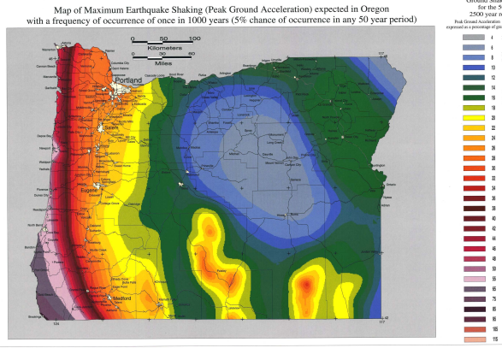
Earthquake Vulnerability
According to Washington County, Portland metropolitan area has experienced six earthquakes of 5.0 magnitude or greater, which flags Portland as earthquake-prone region, as shown in figure 20. Since Hawthorne Bridge is an old structure, it may be more susceptible to damage in the event of a major earthquake

Figure 20 maximum earthquake shaking
Limited Vertical Clearance
Due to Hawthorne Bridge design as a vertical lift bridge, it has a lower vertical clearance of 14.9352 meters compared to another bridge crossing the Willamette River like the Morrison Bridge, a bascule bridge that spans the Willamette River in Portland which has a clearance of 21.0312 meters, Much higher than that of Hawthorne bridge, This low vertical clearance of Hawthorne Bridge can restrict the passage of larger vessels, impacting maritime traffic.
6figure 2

Age and Maintenance
Due to Hawthorne Bridge being the oldest vertical lift bridge in the United States, it requires constant maintenance and repairs to ensure its structural integrity, which can lead to traffic disruption and increased costs for the city to maintain the bridge.

Qasr-Al Nil Bridge
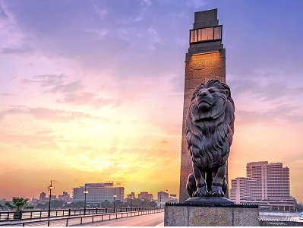
Qasr Al-Nil Bridge is a swing bridge with a movable section that allows boats to pass through the river, connecting downtown Cairo and Western Cairo, it connects Ismailia Square and the western bank of the Nile in Zamalek area similar to the European cities where a bridge links between the cities’ banks. The bridge is primarily made of steel and concrete. The idea to construct this bridge belonged to Khedive Ismail, which is why it was called “Khedive Ismail Bridge” before. It was inaugurated in 1872, and it became the artery of the heart of the Capital. It is 1,932 meters long, which makes it one of the longest bridges across the Nile in Cairo. The bridge is famous for the four bronze lion statues that sit on the ends of the bridge, as shown in Figure 21. It is interesting to note that the four bronze lion statues that were to be installed at each of the entrances to Giza Zoo were placed by Khedive Tawfiq at either end of Qasr El-Nil Bridge, to commemorate the great memory of his sire. Thus, these four lions became an essential part of the structure of the Qasr El-Nil Bridge.
Figure 21 Qasr Al Nil Bridge

Mechanism
Qasr Al-Nil Bridge is a swing bridge with a movable section that allows boats to pass through the river. Swing bridges operate through the rotation enabled by several gear assemblies in conjunction with a rack-and-pinion drive system. In accordance with its size, operator houses and equipment houses that house controls and machinery are mounted on either side of the bridge or on it. These include the Center Pivot, Rim Bearing, and Bobtail. Each type has its classification and advantages, making them suitable for different purposes. Qasr al-nil bridge is a center pivot type swing bridge. The design has a pivotal point in the center of the bridge and allows rotation at that point. The middle pier must be very sturdy as it will carry the weight of the whole bridge when turning. Such a bridge proves helpful at places where the waterway is wide enough for the full length of the bridge to open. The design has a balance in it, allowing ease of the operational function.

Points of Strength

Transportation Hub
Due to its central location in Cairo connecting western Cairo and downtown Cairo, Qasr al-nil bridge is considered to be a very important transportation hub in Cairo and overall essential for transportation and economy.

Historical significance
Qasr al-nil Bridge completed in 1933 has notable historical significance as it represents a symbol of Cairo’s modernization, reliance, and Egypt’s national pride. Furthermore, its strategic location gave it more historical significance as it is located near Tahir Square which made it a focal point in moments of national change.

Architectural Design
Qasr Al-Nil Bridge is admired for its architectural design and aesthetic balance as it blends modern elements with traditional values which can be seen in its modern design with the traditional lions guarding the ends of the bridge.

Points of Weakness

Maintenance Challenges
Despite the sturdy construction of Qasr Al-Nil Bridge, it requires constant maintenance to remain usable and to preserve its structural integrity, delays in this maintenance due to the bridge’s popularity and congestion would lead to deterioration of the bridge’s structure over time.

Pedestrian Overcrowding
Due to Qasr al-Nil Bridge’s popularity, the bridge can become extremely crowded with pedestrians during weekends or holidays as it is a popular location for taking pictures and is considered a tourist attraction. This makes it difficult to walk on the bridge and increases the possibility of car or pedestrian accidents.

Traffic Congestion
Qasr Al-Nil Bridge is one of the major crossings of the Nile River that suffers from severe traffic jams, especially during rush hours, which diminishes the experience for pedestrians and drivers and contributes to the noise and air pollution on the bridge.

THE TOWER BRIDGE IN LONDON
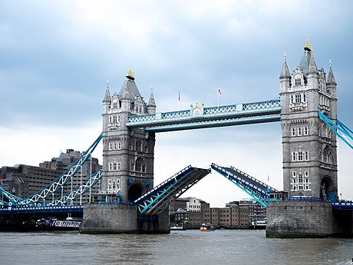
As shown in Figure (22), the Tower Bridge a grade (I) listed marvel stands tall as an iconic symbol of British engineering, spanning the river Thames near the historic Tower of London. The tower bridge was constructed between 1886 and 1894. It was designed by the architect Horace Jones and engineered by John Wolf Barry. Tower Bridge was opened officially on June 30, 1894, by Edward, Prince of Wales, and Alexndra princes of Wales. Since it was opened, the bridge has played a vital role in facilitating transportation and trade, making it a critical link between London’s infrastructure. The length of the bridge is 800 feet (240 meters) with two fantastic towers soaring to 213 feet (65 meters), the bridge boasts a central span divided into two bascules that can be raised to allow passage for waterborne traffic. During the existence of the tower bridge, has externalized the spirit of London by becoming a main part of the heritage of London and its history. It’s in Gothic style architecture that was inspired by the Victorian era.
Figure 22 The Tower Bridge in London

MECHANISM OF THE BRIDGE:
The Tower Bridge is operated with a hydraulic system. The city bridge foundation constructed it. Tower Bridge is a bascule bridge. Bascule is a French word that means seesaw. Each bascule moves around an off-center pivot, which means it looks like a seesaw in a children’s playground. Furthermore, each side of the bascule is evenly balanced, so less energy is required to open up the roads and no pressure is put on the towers. The work of opening and closing the bridge is done by eight large cogs, 1 meter in diameter four on each side, which rotate to close and open the bridge. The required power to rotate the cogs was initially supplied by steam and then in 1976 was by electricity.
Steam was the choice energy during most of the 1800s. At the tower bridge, power was generated by three large boilers fueled by stokers working in shifts, each shift is 24 hours. The steam created in these boilers was used to power the large steam pumping engines in the next room.
The engine's pistons turn large flywheels at the same time as powering a set of hydraulic pumps, which pushes water into six huge storage containers called accumulators. They act like batteries, conserving energy by keeping the water under high pressure.
When the Bridge was required to open, the water was released into the drive engines, powering more pistons to turn a set of cogs these cogs connect to a back on the rack, opening them for passing river vessels. Cogs are still used today to open Tower Bridge, but the power generated is different.
In 1970, it was decided that something needed to be done to make it more efficient, reducing its emissions and making it cleaner.
A new hydraulic system launching began in 1974. Electric pumps were used to create oil-hydraulic energy to turn the cogs and open the bascules. These new engines were set up while the steam system was still in operation, so the Bridge could still open for passing river vessels. In 1976, the work was done. The Tower Bridge became electro-hydraulic powered. The old system was detached.

Points of strength:
Tower bridge efficiency:
Tower Bridge was important in London transportation because it carried 40,000 people and 21,000 vehicles. The bridge's bascules are lifted around 800-1,000 times per year to allow the passage of tall ships and river vessels.
Bascule bridge:
Its strength is that it is a bascule bridge which means that the roads move like two giant seesaws and a fulcrum to open and close the bridge. The word bascule derives from French, meaning "seesaw" or "balance".
Its long life:
Since its completion in 1894, Tower Bridge has gone through many upgrades and efforts showing its flexibility and continued service in modern times. For example, over the past years, Tower Bridge has seen many historical events, such as its important role as a transport link to the port of London during WORLD WAR II. However, the enemy attacked the bridge and it remained strong.

Points of weakness:
1.Traffic:
When the tower bridge opens to pass boat traffic this increases road traffic and disrupts them. Also, it’s a Victorian design, it’s not super accessible with mobility issues.
2. Limited load capacity
When the bridge opens to pass boat traffic this increases the road traffic and disrupts it. Also, it’s a Victorian design, it’s not super accessible to those with mobility issues.
3.Earthquakes bearing
Sensitivity to vibrations. When the bridge bascules (those big see-saw-like sections) open, they're subject to vibrations and oscillations. Over time, this can cause wear and tear, necessitating more frequent maintenance.

Selection Of Solution
After intensive research and analysis of the challenges and the selected location, which is Ismailia Canal, the vertical warren truss bridge design was chosen, with the swing opening mechanism to open for water traffic.

The vertical warren truss design was chosen for its properties, the first of which being efficiency due to the design simplicity as it is composed of equilateral triangles with vertical members connected to the top of each triangle, its design is relatively simple compared to other designs like the Pratt truss or the Howe truss designs and costs less materials, the addition of vertical members to the warren truss bridge was necessary as when the span length increases and the height of the truss necessarily increases, the long compression members in the top chord need bracing to minimize buckling in the vertical direction.

Secondly, the vertical warren design was chosen for its effectiveness as its design of equilateral triangles equally distributes the load among all the members of the design. The equilateral triangles connected with the joint method prevent deformation of the truss structure and keep each member under compression or tension in place.

Thirdly, for our required bridge length of 50 meters, the warren truss bridge fit all the requirements as it is relatively cheap compared to other designs like the Howe or Pratt, as its lack of effectiveness in long distances is irrelevant in this length, and its cheap price and effectiveness made it and even more appealing choice.

The center-bearing swing mechanism was chosen for the bridge due to the properties of the selected location.

Firstly, ​A swing span bridge is a bridge that rotates in a horizontal plane around a vertical axis into a position parallel with the marine channel and shore, allowing boats and ships to pass along a waterway that would otherwise be obstructed by the bridge. Due to the narrow water width of our location along the Ismailia canal of 50 meters, the swing span mechanism was chosen as it is designed to use less water space when open.

Secondly, the center bearing design was chosen as it is lighter and easily operated and maintained as the mechanism is inherently low friction and thus doesn’t require high levels of maintenance or lubrication and its high efficiency as the power required to move than span is less than other movable bridge types and provides an even distribution of loads onto the center bearing.

Selection of prototype:
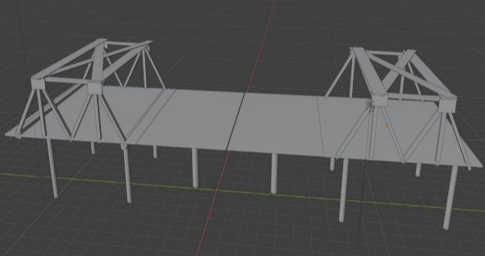
Figure 23 3D design of the prototype
A 3D design was made for the sake of constructing a successful prototype as shown in Figure 23. The prototype's recommended materials should be recyclable and sustainable, like palm trees. While choosing the material for the prototype the term ‘Tensile strength’ should be considered. The tensile strength is the strength of the material and how it performs. Palm trees will be a main component in the prototype. Palm midribs will be used in the manufacturing of trusses and unmovable parts. Palm is a strong material to make the truss. We could divide the strength of the palm tree according to the parts in it. The tensile strength of the palm fiber (Mpa) is 68, and Young’s modulus (Gpa) is 3.774. Palm trees are suitable as they have a distinct structural design that contributes to their strength and can be found anywhere. The truss is made from mild steel with an ultimate tensile strength of 400-550 Mpa and yield strength of 250 Mpa. Steel has things in common with palms as they are both known for their strength in tropical storms. When the palm truss succeeds in the prototype, the real truss will succeed. Palm midribs will be used on the deck and the cords. Thick pillars of the palm tree would be like beams. Syringes and hoses are used between the beam and the bear to open and close the bridge. Syringes and hoses are available everywhere and are suitable as they are the best way to open and close it.

The truss that will be used in the bridge is the vertical Warren truss which can distribute the load equally on the bridge due to the arrangement of the triangles; the Warren truss can hold an average weight of 35.16 kg, and the high and low outliers with a maximum weight of 50.85 kg and a minimum weight of 15.5 kg. The Warren truss is efficient for short bridges, its cost isn’t too much, it is easy to construct, and it's a very stable structure. The number of the 50-meter warren truss with verticals is thirty-six members and twelve diagonals, and it is the same as the prototype, it only differs in physical size. The mechanism of opening and closing the bridge is bascule. A bascule bridge is a movable bridge with a counterweight that continuously balances a span, or "leaf," throughout its upward swing to provide clearance for boat or ship traffic. Counterweights are installed in order to minimize the size of the mechanical power transmission system components needed to operate the bridge, and to provide a relative measure of safety in the event of failure in the mechanical system. The position of this counterweight depends on the type of Bascule bridge. There are four main types of bascule bridges which are simple trunnion, rolling bascule, balance beam bascule, and heel trunnion with swinging counterweight. Although the required torque by the machinery is lowered by changing the gravitational point of the leaf, the counterweight also comes with a downside. Due to the added mass, the mass moment of inertia is increased. According to the equation of motion, this means that an increased mass also requires an increase in force to change the velocity of the mass. This affects the operation of the bridge. A larger torque will be required to start opening the bridge but also to stop the rotation of the bridge. Hydraulic bridges operate through a combination of engineering and fluid dynamics, utilizing the movement of water or oil under pressure to perform mechanical work. Central to this system is the hydraulic actuator, which converts hydraulic energy into mechanical force, enabling bridge movement. These actuators are powered by hydraulic pumps, with the choice of pump—gear, vane, or piston—affecting the bridge’s efficiency and responsiveness. The control valve is crucial for regulating the flow and direction of hydraulic fluid, ensuring precise bridge movement. Modern systems often incorporate advanced electronics and sensors for automated and remote operation, enhancing accuracy and safety through real-time monitoring and diagnostics. The hydraulic fluid’s properties, such as low compressibility, high lubricity, and thermal stability, are vital for smooth operation. Regular maintenance, including fluid filtration and replacement, is necessary to prevent contamination and system failures.

The dimensions of the prototype are as follows: the scale is 1:50. The total length of the bridge is between 80 and 100 cm. The bridge has two lanes of traffic, and the width of the traffic lane is 7 cm. It also has two lanes for pedestrians with a width of 3cm. An island of 2cm exists in the middle width of the bridge. The clearance between the water level and the lowest point of the deck of the bridge is 10 cm. The bridge should allow the passage of ships that need a minimum width of 24cm a maximum width of 28cm and a minimum height of 20cm. The bridge should be able to carry a traffic load of a minimum 10 kg mass at the midpoint of the bridge of the largest fixed span. The maximum deflection at the same point doesn’t exceed 5 cm without collapse. The maximum weight of the prototype shouldn’t be more than 20 kg. By these dimensions, the bridge will meet the design requirements. When the dimensions of the prototype succeed the solution will succeed as These dimensions are well calculated and they will make the prototype efficient. By this, the bridge will allow safe passage of the ships and carry the traffic across water areas.

Design requirements

To make a successful bridge, you must follow these design requirements:
The constructed prototype scale is 1: 50. The length of the bridge should be between 40 and 50 meters. The weight of the prototype shouldn’t be more than 20 kg. The distance between the lowest point of the deck and the sea level should be 5 meters or more. The bridge must have two lanes of traffic vehicles (The width of the traffic lane is 3.5 meters) and two lanes for pedestrians (The width of the pedestrian lane is 1.5 m). An island of 1 m should be provided in the middle width of the bridge. The bridge should allow ships to pass. The ships require a minimum width of 12m and a minimum of 10 meters height over the water surface (table or ground for the prototype) through the movable part of the bridge. The mechanism of opening and closing the movable part of the bridge could be either mechanical or hydraulic. The bridge must carry a simulated "traffic load" of a minimum 10 kg mass (not scaled) placed on the structure at the mid-point of the largest fixed span. The maximum deflection, at the same point, does not exceed 5 cm (not scaled) without collapse. Measure and present a graph of the relationship between the load (increasing from zero to the maximum) and the corresponding deflection at the same point.

Solution requirements

The ability of the Material

The material chosen for the suspension bridge prototype demonstrates exceptional adaptability, particularly for structures requiring both flexibility and support. Its natural composition makes it a versatile resource, easily shaped and crafted to meet precise design specifications. This flexibility allows it to withstand variations in tension and compression, adjusting to shifts in weight and load distribution without compromising structural integrity. Additionally, the material’s lightweight nature reduces the strain on the bridge’s foundation, enhancing stability. This adaptability is invaluable in prototype development, as it simplifies the construction process and reduces the need for complex adjustments during assembly.

Strength of the Material

Remarkably strong and resilient, the chosen material can endure considerable loads and resist wear over time. It is characterized by a sturdy core, which provides the bridge with a reliable base capable of supporting pedestrian or light vehicular traffic as intended in prototype testing. Despite its moderate weight, this material boasts impressive tensile strength, ideal for withstanding dynamic forces on a suspension bridge. Its fibrous structure enhances durability, allowing it to absorb shocks from movements and environmental forces, such as wind or minor seismic activity. This robust quality ensures the bridge remains safe and effective throughout its lifespan.

Sustainability of the Material

Sustainability is one of the standout advantages of this material, as it originates from a renewable, widely available source that minimizes environmental impact. Unlike conventional construction materials, its use promotes eco-friendliness and helps reduce dependency on finite resources. The material’s biodegradable nature also means it leaves a minimal footprint, aligning well with environmentally conscious building practices. Additionally, utilizing locally sourced materials cuts down on transportation emissions and supports regional economies. This sustainable characteristic not only benefits the environment but also aligns with modern engineering goals, making it an ideal choice for eco-friendly infrastructure projects.

Chapter 3: Constructing Prototype:
Materials and methods:

Table 1 Materials used in the prototype
Material | Description |  | Usage | Quantity | cost | Picture | Source of purchase
Palm midrib | Midribs made of date palm midrib |  | It is used as a material for making trusses, decks, and pillars. | 36 rods | 432 L.E | 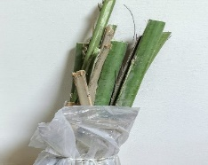 | Mansoria street in kerdasa
Adhesive glue(mdf) | Sticky material |  | It is used as a sticky material to stick the different parts of the bridge | 2 bottles | 75 L.E |  | Paint seller in Shubra elkhima
Steel wires | Made of steel |  | Connecting between the midrib rods in the truss and the deck. | 1 | 60 L.E |  | From home
Syringes | Made of plastic | It is used as a hydraulic lifter |  | 5 | 20 L.E | 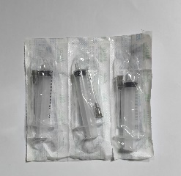 | Pharmacy in Shubra elkhima
Glue gun | Work by electricity | It is used to stick |  | 1 | owned | 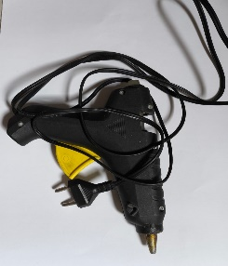 | From home
Hose | Made of plastic | It is used to transfer water from one syringe to the other syringe |  | 3 | 52 L.E | 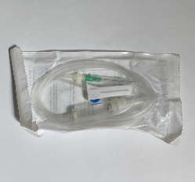 | Pharmacy in Shubra elkHima
Measuring tape |  | It is used to measure the length of every component in the bridge |  | 1 | owned |  |  | From home
Nails | Made of iron | It’s used to connect the deck with the truss and the rest components with each other. |  | 2 boxes of nails | owned |  |  | From home

•To construct a successful prototype, a 3D design was first created to visualize its shape.
•Nearly perfect cuboids were cut off from the palm midribs to be used as the main part of the construction
•The bridge was divided into two fixed spans and a movable one consisting of 2 moving leaves.
•A warren truss with verticals was constructed, the members are from palm midrib.
• The palm midrib was cut into members and attached with adhesive glue and nails.
•The base of the deck was constructed 1 meter in length and then cut round cylinders to the role of the piers and stuck to the deck.
•Two other piers and two syringes were put in them to act as the 2 hydraulic lifters.
•A hole was made in the two piers to put a hose in the two syringes to pump water into them.
•The hose was connected to another syringe outside of the bridge used to pump water into the one that’s inside.

Safety precautions:
While constructing the prototype, some safety precautions should be followed to prevent any dangerous injury and ensure safety. In this prototype, the safety precautions were as follows: wearing safety gloves to prevent hands from being cut from the saw. Wear safety boots to prevent sawdust from getting into your feet. Wear safety goggles to protect your eyes from getting hurt. Wear a safety coat to protect your body from getting hurt. While using the saw blade, a double layer of cartoon was put around it to make its handle safer. A wooden ruler was constructed with holes inside it with the needed measurements to cut to protect fingers from being cut.
Test plan:
A test plan should be performed to determine the prototype's efficiency and whether it works or not.
1-The test plan for this prototype was to put a kilo by kilo to 5 kg to see if the bridge could bear this weight.
2-After that, 10 kilos were placed on the fixed span to test the strength of the bridge.
3-Then, the bridge measurements were revised so that they all were correct and accurate and matched the design requirements. To get accurate results, measurements should be measured by millimeters and look horizontally at the measuring tape.
4-To test the deflection in the bridge, the used machine is the motion sensor.

Data collection:
A measuring tape was used to measure the lengths of the deck, members, and piers, alongside with a stick cut to be 1M used as a scale to cut the midribs on, it is like a ruler from wood.
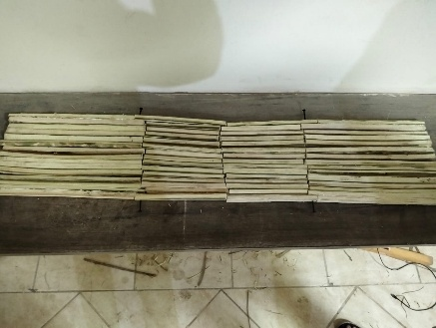
Negative results:
Figure 24 Deck with error.
- When the deck was constructed and measured, the results stated that the widths of the two ends of the deck weren’t equal as shown in Figure 24, so it was reconstructed using straighter parts and a right triangle to check the angles.

- When the movable part was glued, it wasn’t strong enough and broke, so we used nails to ensure its strength as shown in Figure 25.
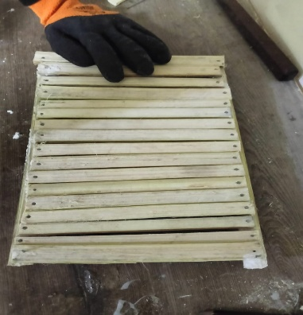
Figure 25 accurate deck.

- When the mechanism was tested, the syringe lifted the movable part but alongside the fixed part because the fulcrum wasn’t light enough, so a lighter fulcrum was used to fix the problem.

Positive results:
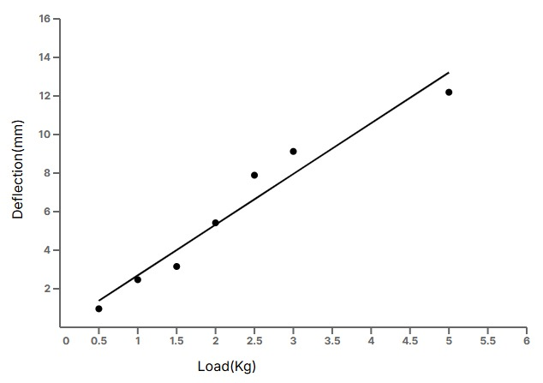
- After constructing the deck, the load was put on the deck and continuously increased to test the deflection, and the results were as shown in Figure 26.

- After opening the bridge, an empty area of 24*20 Cm^2 was provided to allow ships access.

- The prototype was put on a scale for mass testing, and the result was 3.5 KG.
Fig.26 deflection to load graph

Table 2 errors in the lengths of the prototype
Object | Length | Width | Height | Unit
Diagonal truss member | 13±0.05 | 0.5±0.05 | 0.5±0.05 | CM
Vertical truss member | 11.5±0.05 | 0.5±0.05 | 0.5±0.05 | CM
Fixed part of the deck | 30±0.05 | 22±0.05 | 4±0.05 | CM
The movable part of the deck | 20±0.05 | 22±0.05 | 2±0.05 | CM
beam | 0.5±0.05 | 0.5±0.05 | 10±0.05 | CM

Table 3 Deflections in the Bridge
Deflection (mm) | Load (Kg)
0.9604 | 0.5
2.4696 | 1
3.1556 | 1.5
5.4194 | 2
7.8890 | 2.5
9.1238 | 3
12.1922 | 5

Chapter 4: analysis and discussion:
Analysis:
Force analysis:
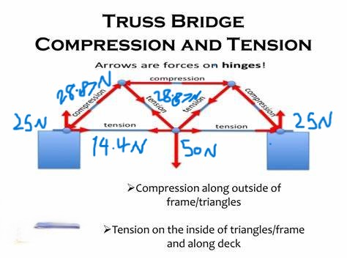
Force analysis is how to distribute the force on the members of the truss. When conducting a truss analysis for the bridge, it is important to know the forces acting on the truss members under the given
Figure 27 force analysis
load, which is 5 kg (50 newtons).
$$\sum{ fx=zero, \sum{fy=zero} }\sum{M=zero}$$
The Fx is the force acting on the x-axis, the Fy is the force acting on the y-axis, and m is the moment, all of them are equal to zero because the bridge is in equilibrium. The release of the truss system from external supports and the equilibrium conditions for whole truss external reactions were computed and from equilibrium conditions for released joints unknown axial forces were computed in members. By starting with the joint in which external forces (or reactions) are known and where there is a maximum of two unknown axial forces. The members in which there are zero forces are called zero members (vertical members). Even if those forces are not loaded, they are necessary for ensuring the stability of the truss. By using the method of joints to distribute the forces the following results have appeared that the compression members can lift a force of 28.87 newtons and the tension member can lift 14.4 newtons as shown in Figure 27.

Young’s modulus:
Young’s modulus is a fundamental mechanical property that is used to measure the stiffness of a material. Young’s modulus is defined as the stress of the material (force per unit area) to the strain of the material (Length/ change in the length) $E=\frac{stress}{strain}=\frac{F/A}{∆L/Lo}$ , where E is the Young’smodulus, F is the force, A is the area, $∆l$is the change in length, and $lo$is the original length. The palm midrib, which is the central structure support of the palm trees, has gained attention due to its unique properties like stiffness and durability. It helps you to choose the best material for the prototype model. In this prototype, the used material is the palm tree. The results show that the eight parts of date palm wood consist mainly of cellulose, hemicellulose, and lignin with an average of 40, 20, and 28 wt%, respectively. They are characterized by low value of density which is generally less than 600 kg/m^3 and low rate of water absorption. Date palm wood ranges among the materials that have weak mechanical properties (the tensile strength ranged from 86 to 213 MPa, Young’s modulus ranged from 3 to 8.5 GPa, and elongation at break close to 3%); however, it is characterized by high specific properties which constitute one of the principal advantages of using it to develop lightweight and high strength materials. To calculate the change in the length of the palm midrib it was 0.8248μm(micrometers) with young’s modulus of 7 Gpa in compression and the tension was 0.4113μm(micrometers), so the strain of the palm midrib in compression was 6.3446×10^-6 and that in tension is 3.1646×10^−6.

Deflection:
The deflection of a beam refers to the amount it bends under a given load. It can be calculated using different methods and instruments, the method used for calculating the deflection in the bridge is by measuring the distance from a point facing the deck bottom to the deck without any load applied to the deck, then, a load is applied to the center of the deck and the measurement is taken once more, this process is repeated seven times, each time with a higher load than the latter, afterward, the distances from the loaded decks to the point is subtracted from the distance of the load-free deck to the point where d1 – d2 = deflection at the load of d2 where d1 is first distance and d2 is the second distance. The measurement (distance) was taken by motion detector 2, where short bursts of ultrasonic sound waves are emitted by the motion detector from the gold foil of the transducer, a cone-shaped area about 15 to 20° off the axis of the centerline of the beam is filled by these waves. The Motion Detector then “listens” for the echo of these ultrasonic waves return. The duration taken for the ultrasonic waves to make the trip from the Motion Detector to an object and back is then measured. Using the time taken and the speed of sound in the air the distance to the nearest object is then determined through the following equation, d=1/2vt where d is the distance to the object, v is the speed of sound in air and t is the time taken for the ultrasonic waves to travel from the motion detector to the object and back.
$$d1-d2=deflection at the load of d2$$

Pascal law:
The law states that a change in pressure at any point in an enclosed fluid at rest is transmitted undiminished to all points in the fluid, which is represented in the formula F1/A1 = F2/A1.

$P=\frac{F1}{A1}=\frac{F2}{A3}$

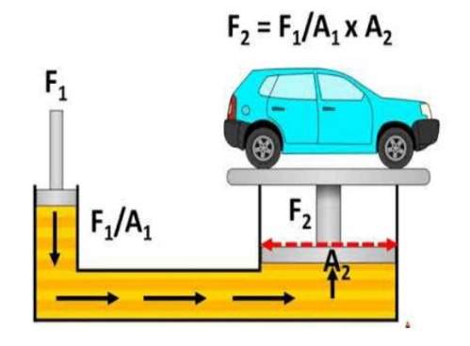
(A1) is the area of the surface that applies the pressure to the fluid. (F1) is the force exerted by the surface that applies the pressure to the fluid. (A2) is the area of the surface that is pushed by the force of the fluid. (F2) is the force exerted by the fluid at the other side of the tube. The Pascal law is used to double the force in a particular mechanism with less energy. It’s very helpful as you may lift or hold very heavy objects with mere force as shown in Figure 28. For instance, if you enclose fluid in a tube that’s 1cm^2 on one side and 50cm^2 on the other side. When a 100N force is exerted on the small side, the other side can hold a force equal to 5000N. In the prototype, it’s used to apply the force needed to lift the bridge by transmitting a small force through it. This principle was applied in the project to calculate the force needed to lift the movable part of the deck, and the result was 12.5 N.
Figure 28 hydraulic system

Conclusion:
The prototype applied all the design requirements, and it’s applicable in real life. Force analysis was made to define the distribution of forces on the truss members. By using the method of joints to distribute the forces the following results have appeared that the compression members can lift a force of 28.87 newtons and the tension member can lift 14.4 newtons. Young’s modulus was used to measure the stiffness of the palm midribs. The tensile strength ranged from 86 to 213 MPa, and Young’s modulus ranged from 3 to 8.5 GPa. Pascal's law was used to calculate the force needed to lift the movable part of the deck in terms of the area of the syringes. A force equal to 12.5N was required to lift the deck using the syringes. After constructing the deck, the load was put on the deck and continuously increased to test the deflection, and the results were 2.4696mm/Kg. After opening the bridge, an empty area of 24*20 CM^2 was provided to allow ships access.

Recommendation:
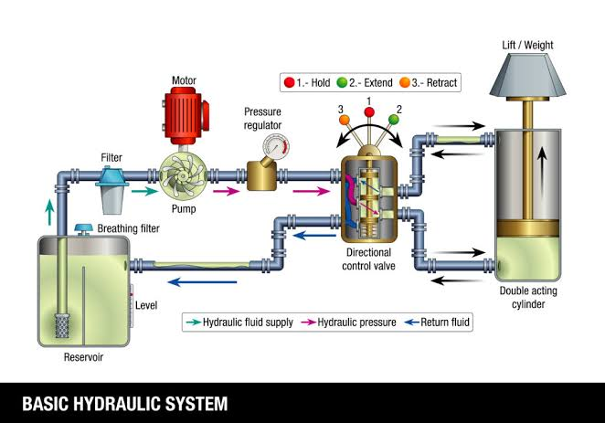
Mechanical hydraulic:
Figure 29: mechanical system
While choosing the mechanism, it’s recommended to use a mechanical hydraulic system, instead of, a manual hydraulic. A mechanical hydraulic is made with a huge cylinder, gears, a motor, and a pumping pistol. The motor is connected to the gears, which are also connected to the pumping pistol, all inside the cylinder. Hydraulic fluid, which is a special material used in hydraulic systems, is contained in the cylinder between the pumping pistol and the slave pistol. When the motor is turned on, the gears rotate in the system making the pistol pump the hydraulic fluid pushing the slave pistol and lifting the deck as illustrated in Figure 29. It is better than its manual equivalent because it will be able to hold the load of the traffic better, and because turning on the mechanism is easier as it doesn’t need the effort needed in a manual hydraulic. It wasn’t used because there weren’t any small motors available. More research can be done using modern technology in the future.
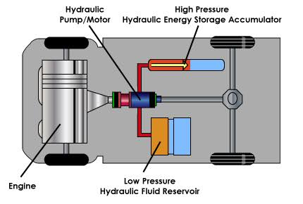
Energy recovery system:
In the construction of the bridge, a generator inside the hydraulic system can be added. A system that can take advantage of the kinetic energy produced by the fluid pumped in the cylinder, and recover the energy consumed by the motor, can be best described as an Energy Recovery System. This system includes small water wheels built in. When the hydraulic fluid moves these water wheels are rotated, which produces energy that can be used in the motor by connecting it with the system as illustrated in Figure 30. This system recovers the energy consumed by the motor and converts it to be used in the motor again, which is why it’s called an energy recovery system. This system wasn’t applied in the current project because the technology needed was out of reach.
Figure 30: Energy recovery system

Eco-friendly hydraulic fluid:

While constructing the mechanism, a specific fluid is used as the main part of the hydraulic. Hydraulic fluids are fluids made specifically for hydraulics. It’s recommended to use eco-friendly hydraulic fluids, like biodegradable hydraulic fluids shown in Figure 31. These fluids do not contain mineral lubricating oils; they are based on high-quality vegetable oil esters, which are more easily biodegraded, less hazardous, and more suitable for use in environmentally sensitive areas in comparison with mineral oil-based lubricants. Using these hydraulic fluids will reduce pollution as they are eco-friendly and don’t include any polluting elements. It wasn’t applied in this project for two reasons; it’s not available in Egypt, and its high cost was a preventive to use it.
Figure 31: biodegraded fluid
Hydraulic fluid heat controlling system:
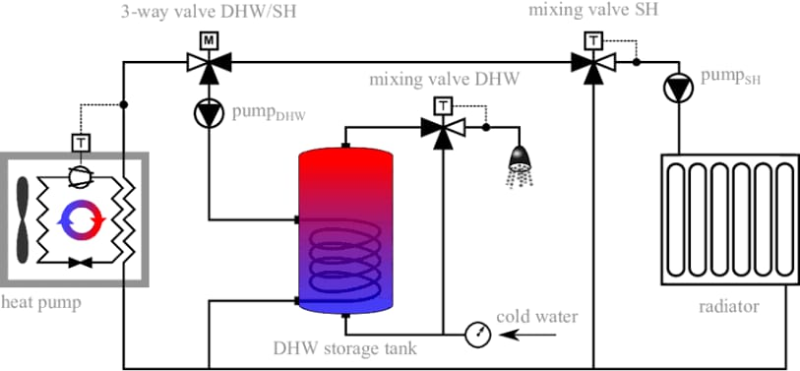
When the cylinders are constructed, a hydraulic fluid heat-controlling system is essential as shown in Figure 32. During the changes between seasons and the change in climate and temperature, the hydraulic fluid expands and condenses. To solve this problem a hydraulic fluid heat controlling system is added to the mechanism, and it can be powered using the energy produced from the energy recovery system. It is programmed to keep the temperature of the hydraulic fluid constant, preventing the expansion of the fluid. It’s vital as the expansion of the hydraulic fluid is capable of destroying the whole project. This wasn’t possible due to the limitations of the materials and the complexity of installing the hydraulic fluid heat controlling system as it’s dangerous to use because it can damage the palm midribs.
Figure 32: heat controlling system

What recommendations do you have for future work in this area?
The bridge was constructed in a way that makes it bear harsh conditions and hazards but absolutely, the bridge isn’t perfect, so, some modifications will be applied to the bridge. I recommend the people who will work after me to search more in the field of construction of bridges.
I recommend using a mechanical hydraulic mechanism instead of a manual hydraulic as it is more effective in the bridge, but it is out of reach. Using an energy recovery system saves more energy in the mechanism as it recovers the energy consumed by the motor and converts it to be used in the motor again.
I recommend using hydraulic fluid, like biodegradable hydraulic fluid, because it’s non-polluting for the environment.
I recommend using a hydraulic fluid heating system; it solves the problem of expansion and condensation of the hydraulic fluid, but it can burn the palm midribs.

How did this cap help you and your team become a better stemmer?
In this capstone project, my team and I learned a lot about science, architecture, and construction skills. We learned and practiced through hard work and strong well, where we all pushed each other as a connected team.
The stress the capstone project put us in, taught us how much responsibility we need to have to achieve success in our life and business. Since we always have multiple tasks at a time between presentations and the capstone tasks, as always active students we learn how to arrange our tasks in the time we have, which makes us better stemmers.
Through capstone research, we figured out many interesting information and laws of physics and mechanics and we got a better understanding of the forces and the force distribution in bridges. From a daily word that we use and see almost all the time, the project made the word bridge more than just that. A bridge became a lifestyle for us, as we almost know everything about it. The project gave us a bigger preview of bridges and we will never see it the same.

Learning outcome:

Table 4 lo connections
Chemistry lo1 | This lo illustrates the errors in measurements and accuracy used in the prototype to determine the error in the weight that it lifts. | Math lo2 | This lo explains the graphs and their types, so representing data from the test line equation could be easier. A scatter plot can be used to measure the deflection of the bridge while increasing the force acting on the bridge.
Physics lo2 | This lo explains the forces and how to distribute them, in the prototype it is used to determine the forces applied to the members. | E.S lo3 | This lo analyzes and identifies the earth materials that are used as a resource for modern buildings and integrates design criteria and material properties in choosing materials for engineering design. So, it is very useful in choosing the materials that suit the design requirements.
Physics lo6 | This lo explains Young’s modulus, which can be used to determine the stiffness of the material used in the bridge. | Mechanics lo4 | This lo explains force as a vector; the force has magnitude and direction, so the force that is downwards is positive, then the force upward is negative with the same magnitude, so they cancel each other.
Physics lo7 | This lo clarifies the tension and compression of the bridge, so it could be used in the bridge to determine the members that have tension and the members that have compression. | Math lo1 | This explains the sine and cos laws that are used in determining the length of any member in the truss, the formula of cos law is (c² = a² + b² − 2ab cos(C)).
CS lo1 | This lo explains the Sketchup program that is used in designing the 3D model of the bridge for the sake of constructing a successful prototype. | ENL LO1 | This lo explains the structure of the paragraph, which helps us to write the portfolio and the poster.

Literature citation:
ECORYS Nederland BV, SETS Lebanon, World Bank, Government of Egypt, Nakat, Z., & Herrera, S. (2010). Cairo Traffic Congestion Study Phase 1 Final report.

World Bank. (n.d.). TRAFFIC CONGESTION IN CAIRO: AN OVERVIEW OF THE CAUSES AS WELL AS POSSIBLE SOLUTIONS. https://www.worldbank.org/content/dam/Worldbank/document/Cairo-Traffic-Congestion-Study-Overview-Final.pdf

ECORYS Nederland BV, SETS Lebanon, World Bank, Government of Egypt, Nakat, Z., & Herrera, S. (2010b). Cairo Traffic Congestion Study Phase 1 Final report. https://documents1.worldbank.org/curated/ru/650141468248419267/pdf/718450ESW0Whit0ing0Annexes00PUBLIC0.pdf

DesignHorizons Team. (2024, October 22). Hydraulic Bridge Systems: Operation, Components, and Innovations - DesignHorizons. DesignHorizons. https://designhorizons.org/hydraulic-bridge-systems-operation-components-and-innovations/

Abo-Elnor, M. E. (2022). Analysis of different bascule bridge architectures. WSEAS TRANSACTIONS ON APPLIED AND THEORETICAL MECHANICS, 17, 86–94. https://doi.org/10.37394/232011.2022.17.12
Lengvarský, P., & Bocko, J. (2016). The static analysis of the Truss. American Journal of Mechanical Engineering, 4(7), 440–444. https://doi.org/10.12691/ajme-4-7-38.
Roark, R. J., Young, W. C., & Budynas, R. G. (2002). Roark’s Formulas for Stress and Strain. McGraw Hill Professional.

Almi, K., Benchabane, A., Lakel, S., & Kriker, A. (2015). Potential utilization of date palm wood as composite reinforcement. Journal of Reinforced Plastics and Composites, 34(15), 1231–1240. https://doi.org/10.1177/0731684415588356.

Pascal’s Principle and Hydraulics. (n.d.). https://www.grc.nasa.gov/www/k-12/WindTunnel/Activities/Pascals_principle.html.

Tkáč, Z., Čorňák, Š., Cviklovič, V., Kosiba, J., Glos, J., Jablonický, J., & Bernát, R. (2017). Research of biodegradable fluid impacts on the operation of tractor hydraulic Systems. Acta Technologica Agriculturae, 20(2), 42–45. https://doi.org/10.1515/ata-2017-0008\.

Egypt geography, maps, climate, environment and terrain from Egypt | - CountryReports. (n.d.). https://www.countryreports.org/country/Egypt/geography.htm

Makumbe, P., Mot, M., Moustafa Khalil, M., Hallouda, M., International Bank for Reconstruction and Development, & World Bank. (2017). Energy efficiency and rooftop solar PV opportunities. https://documents1.worldbank.org/curated/en/578631498760292189/pdf/Final-Output-Summary.pdf

Using saline water for irrigation. (n.d.). https://www.dpi.nsw.gov.au/agriculture/soils/more-information/salinity/salinity-and-crops/saline-irrigation#:~:text=Acceptable%20salinity%20levels,about%2010%25%20loss%20of%20yield.

Agricultural land per capita. (2024, February 15). Our World in Data. https://ourworldindata.org/grapher/agricultural-area-per-capita

SE Hawthorne and Madison multimodal improvements. (n.d.). Portland.gov. https://www.portland.gov/transportation/pbot-projects/ccim/construction/se-hawthorne-and-madison-multimodal-improvements

Schlicker, H. G., *, Deacon, R. J., **, Twelker, N. H., ***, The Alaska, State of Oregon Department of Geology and Mineral Industries, Portland, Oregon, Seattle, Washington, Berg, & Baker. (1964). EARTHQUAKE GEOLOGY OF THE PORTLAND AREA, OREGON. The ORE BIN, 209. https://pubs.oregon.gov/dogami/og/OBv26n12.pdf

Rodda, B. N. (n.d.). Vertical Lift bridges – Raising the roof on bridge design – The Bridge Guy. https://thebridgeguy.org/2021/08/vertical-lift-bridges-raising-the-roof-on-bridge-design/

Other Landmarks details. (n.d.). http://www.cairo.gov.eg/en/Culture/Pages/Other-Landmarks-details.aspx?ID=3

The Warren Truss. (n.d.). https://www.structuremag.org/article/the-warren-truss/

NCDOT. (n.d.). https://www.ncdot.gov/initiatives-policies/Transportation/bridges/historic-bridges/bridge-types/Pages/swing-span.aspx

Egypt | Department of Economic and Social Affairs. (n.d.). https://sdgs.un.org/basic-page/egypt-34124#:~:text=About%2090%25%20of%20Egypt's%20water,from%20non%2Drenewable%20subterranean%20water

Egypt geography, maps, climate, environment and terrain from Egypt | - CountryReports. (n.d.b). https://www.countryreports.org/country/Egypt/geography.htm

Arab Republic of Egypt, Ministry of Agriculture and Land Reclamation, & Desert Research Center. (2018). Final Country Report of the Land Degradation Neutrality Target Setting Programme. https://www.unccd.int/sites/default/files/ldn_targets/2019-02/Egypt%20LDN%20TSP%20Country%20Report.pdf

Ritchie, H., Roser, M., & Rosado, P. (2020, May 11). CO₂ and Greenhouse Gas Emissions. Our World in Data. https://ourworldindata.org/energy/country/egypt

Makumbe, P., Mot, M., Moustafa Khalil, M., Hallouda, M., International Bank for Reconstruction and Development, & World Bank. (2017b). Energy efficiency and rooftop solar PV opportunities. https://documents1.worldbank.org/curated/en/578631498760292189/pdf/Final-Output-Summary.pdf

Statista. (2024, May 17). Total solar energy capacity in Egypt 2012-2023. https://www.statista.com/statistics/1215515/egypt-total-solar-energy-capacity/#:~:text=As%20of%202023%2C%20the%20solar,the%20capacity%20remained%20relatively%20stable

The desert biome. (n.d.). https://ucmp.berkeley.edu/exhibits/biomes/deserts.php

Egypt - Western Desert. (n.d.). https://countrystudies.us/egypt/50.htm

Capmas. (n.d.). https://www.capmas.gov.eg/Pages/populationClock.aspx

World Population Dashboard -EGYPT | United Nations Population Fund. (n.d.). United Nations Population Fund. https://www.unfpa.org/data/world-population/EG

